To: |  | City Executive Board
Date: |  | 15 September 2016
Report of: |  | Head of Financial Services
Title of Report: |  | Treasury Management Annual Report 2015/2016
Summary and recommendations
Purpose of report: |  | The report sets out the Council’s treasury management activity and performance for the financial year 2015/2016. The report also identifies some reductions in interest rates in 2016/17 and recommends a change to the Treasury Strategy for 2016/17.
Key decision: |  | No
Executive Board Member: |  | Cllr Ed Turner, Finance, Asset Management and Public Health
Corporate Priority: |  | An Efficient and Effective Council.
Policy Framework: |  | Treasury Management Strategy.
Recommendations: That the City Executive Board resolves to:
1. | Note the report
2. | Recommend that Council approve the amendment to the Specified Investments list attached at Appendix 1 (paragraphs 35 – 37 below)

Appendices
Appendix 1 | Amended Specified Investments List

Executive Summary
- The Council held investments of £64.26 million as at 31 March 2016. Interest earned during the year was £0.86 million against an income target of £0.94 million.
- The average rate of return on the Council’s investments in 2015/2016 was 1.17% compared to 1.18% in 2014/15. This was above the Council’s performance target of 1.0% (i.e. 0.5% above base rate) and is primarily due to investments in property funds off-setting market investment rates which have fallen to very low levels.
- The Council has £0.166 million outstanding with the failed Icelandic Banks. £0.217 million was received in year, and it is expected that the majority of the remaining funds will be received in due course. Further information can be found in paragraphs 25-27.
- The Council held £198.5 million of fixed rate Public Works Loan Board (PWLB) debt as at 31 March 2016. The debt was borrowed in March 2012 to fund the buy-out of the Housing Revenue Account (HRA). All of the debt relates to Housing and the maturity profile ranges from 5 to 41 years. Interest paid on the debt in 2015/2016 was £6.47 million.

Background
The primary principle governing the Council’s investment decisions is the Security of the investment, with Liquidity and Yield being secondary considerations.
The Council has a statutory duty to set, monitor and report on its prudential indicators in accordance with the Prudential Code, which aims to ensure that the capital investment plans of authorities are affordable, prudent and sustainable.
When considering whether to borrow, the Council’s Debt Strategy requires a number of factors to be considered. These include:
    - prevailing interest rates
    - the profile of the Council’s debt portfolio
    - the type of asset being financed
  - the availability of cash balances to finance capital expenditure.

The Council fully complied with its Treasury Management Strategy in relation to both debt and investment management in 2015/2016.
The prudential indicators detailed in the body of this report compare the Council’s outturn position against the target set for 2015/16.
Financing the Capital Programme 2015/16
Table 1 below shows actual capital expenditure and financing compared to the original budget.
Table 1
Capital Expenditure | 2015/16 | 2015/16 | Variation
 | Original Budget | Actual
 | £'000 | £'000 | £'000
Non-HRA Capital Expenditure | 17,858 | 17,129 | (729)
HRA Capital Expenditure | 21,047 | 15,579 | (5,468)
Total Capital Expenditure | 38,905 | 32,708 | (6,197)
Resourced by:
Developer Contributions | 2,754 | 706 | (2,048)
Capital Receipts | 7,288 | 9,765 | 2,477
Capital Grants and contributions | 947 | 6,336 | 5,389
Major Repairs Reserve | 6,858 | 8,177 | 1,319
Prudential Borrowing | 3,268 |  | (3,268)
Revenue | 17,790 | 7,724 | (10,066)
Total Capital Resources | 38,905 | 32,708 | (6,197)

There was also £8.674 million carried forward into 2015/16 from 2014/15 giving a revised budget of £47.579 million. The outturn position shows that £14.87 million less than the budget has been spent. The temporary moratorium imposed on both General Fund and HRA Capital schemes agreed by members at CEB on the 10th September (lifted in December) due to uncertainties around Government funding especially in the HRA was the main cause of the underspend. Overall spend was 69% of the budget compared to 76% (£48.7million spent) in 2014/15. Major variations to the Capital Programme were reported in detail to the June 2016 meeting of this Board.
It was originally planned to take out prudential borrowing to finance HRA expenditure, however the HRA new build investment plans had to be scaled back due to Government legislative proposals which led to a revision of the Programme and its financing. The use of capital grants and contributions were higher than budgeted; the main reason for this was additional funding received for the Oxpens development site.
The Council’s Overall Borrowing Need
The Council’s underlying need to borrow, or Capital Financing Requirement (CFR), is a gauge of the Council’s level of indebtedness. It represents all prior years’ net capital expenditure which has not been financed by other means, i.e. revenue, capital receipts, grants etc.
The CFR can be reduced by:
  - The application of additional capital resources, such as unapplied capital receipts; or
  - By charging a Minimum Revenue Provision (MRP), or a Voluntary Revenue Provision (VRP)

Table 2 below shows the Council’s CFR as at the 31 March 2016, this is a key prudential indicator, and shows that actual borrowing is below the CFR:

Table 2
CFR | 31 March 2016 | 31 March 2016 | Variation
 | Estimate | Actual
 | £'000 | £'000 | £'000
Opening Balance | 222,962 | 220,706 | (2,256)
Prudential Borrowing | 3,268 | 0 | (3,268)
Minimum Revenue Provision | (1,113) | (37) | (1,076)
CFR Closing Balance | 225,117 | 220,669 | (4,448)
External Borrowing | 201,770 | 198,528 | (3,242)
Variation | (23,347) | (22,141)

No new debt was taken out during 2015/16 and as at 31 March 2016 the Council’s total external debt was £198.5 million. This is below the CFR and indicates that the Council continues to internally borrow. The MRP was reduced from that estimated due to: a) the decision to fund new vehicles from capital receipts in 2014/15 and hence no MRP being required for borrowing in relation to vehicles in 2015/16 and b) a reduction in the MRP that the Council makes on the non-Housing assets transferred from the HRA to the General Fund due to a reassessment of the calculation.
Treasury Position at 31 March 2016
Whilst the Council’s gauge of its underlying need to borrow is the CFR, the treasury function manages the Council’s actual borrowing position by either:
  - Borrowing to the CFR;
  - Choosing to utilise temporary cash flow funds, instead of borrowing (known as “under borrowing”);
  - Borrowing for future increases in the CFR (borrowing in advance of need)
The Council’s treasury position as at the 31 March 2016 for both debt and investments, compared with the previous year is set out in Table 3 below:

Table 3
 | 31 March 2015 |  | 31 March 2016
Treasury Position | Principal | Average Rate | Principal | Average Rate
 | £'000 | % | £'000 | %
Borrowing
Fixed Interest Rate Debt | 199,423 | 3.39 | 198,528 | 3.15
Total Debt | 199,423 | 3.39 | 198,528 | 3.15
Investments
Fixed Interest Investments | 35,200 | 0.53 | 46,500 | 0.64
Variable Interest Investments | 5,890 | 0.42 | 7,760 | 0.44
Property Funds | 9,800 | 4.03 | 10,000 | 4.05
Total Investments | 50,890 | 1.18 | 64,260 | 1.17
Net Position | 148,533 |  | 134,268

The average investment rate shown above is 1.17% for 2015/16 which is above the Council’s target of 0.5% above base rate (1% in total). Despite this, the Council did not achieve the level of investment income that had been budgeted by £0.080 million. This is because the budget had incorporated anticipated rises in base rates which was the market intelligence at the time the budgets were set. The lack of a base rate rise had led to the situation of the budgeted income not being achieved even though performance against the target of 0.5% above base rate was achieved.

Prudential Indicators and Compliance Issues
Some of the prudential indicators provide an overview, others a specific limit on treasury activity. These are detailed below:
Net Borrowing and the CFR – In order to ensure that borrowing levels are prudent, the Council’s external borrowing (net of investments) over the medium-term must only be for a capital purpose, and not exceed the CFR except in the short-term. In the short term the Council can borrow for cash flow purposes, although this has not been necessary in recent years. Table 4 below highlights the Council’s net borrowing position against the CFR, and shows that it is significantly below the limit, due to the level of internal borrowing that has been undertaken.

Table 4
Net Borrowing & CFR | 31 March 2015 | 31 March 2016
 | Actual | Actual
 | £'000 | £'000
Total Debt | 199,423 | 198,528
Total Investment | 50,890 | 64,260
Net Borrowing Position | 148,533 | 134,268
CFR | 220,706 | 220,669
Under Borrowing plus Investments | 72,173 | 86,401

In the current climate, internal borrowing is preferable to borrowing externally as the interest rate payable on an external loan is much higher than that which can be earnt on investments. Therefore, forfeiting interest receivable on investments is more economical than paying additional interest charges for new external debt. Clearly, if the net borrowing position and/or CFR changed significantly, the prospect of taking on additional debt would be reviewed.
The Authorised Limit – The Authorised Limit is the ‘affordable borrowing limit’ required by S3 of the Local Government Act 2003. The Council does not have the power to borrow above this level unless it explicitly agrees to do so. Table 5 below demonstrates that during 2015/16 the Council’s gross borrowing was within its Authorised Limit. The Authorised Limit allows the Council to borrow against the future CFR if required, with a little headroom.

Table 5
Authorised Borrowing | 31 March 2015 |  | 31 March 2016
 | Estimate | Actual | Estimate | Actual
 | £'000 | £'000 | £'000 | £'000
Borrowing | 247,000 | 199,423 | 247,566 | 198,528
Other Long Term Liabilities | 0 | 0 | 0 | 0
Total Borrowed | 247,000 | 199,423 | 247,566 | 198,528
Amount under Limit | 47,577 |  | 49,038

The Operational Boundary Limit – the Operational Boundary Limit is the expected borrowing position of the Council during the year. It is possible to exceed the Operational Boundary Limit, for a short period of time, providing that the Authorised Borrowing Limit is not breached. Table 6 below shows the limits for the last two financial years. They were not breached during either period.

Table 6
Operational Boundaries | 31 March 2015 | 31 March 2016
 | £'000 | £'000
Borrowing | 236,000 | 234,000
Other Long Term Liabilities | 0 | 0
Totals | 236,000 | 234,000

Actual financing costs as a proportion of net revenue stream – this indicator identifies the trend in the net cost of capital against the net revenue stream and is an indicator of affordability. Table 7 below shows that for the General Fund, the ratio is negative as external loans have been repaid and investment income is positive. The HRA ratio has improved slightly due to an increasing income stream meaning that financing costs as a proportion have fallen.

Table 7
Actual Finance Costs | 2014/15 | 2015/16
 | £'000 | £'000
Indicators
Original Indicator - Authorised Limit | 247,000 | 247,566
Original Indicator - Operational Boundary | 236,000 | 234,000
Financing Costs as a proportion of Net Revenue Stream - General Fund | -0.15% | -0.09%
Financing Costs as a proportion of Net Revenue Stream - HRA | 17.7% | 16.8%

Icelandic Banks
During 2008/09 the Council invested £4.5 million with two of the now failed Icelandic banks: £3.0 million was deposited with Heritable Bank and £1.5 million with Glitnir Bank.
As at 31 March 2016, the Council had received approximately £2.94 million of its original Heritable Bank investment. A repayment of £0.119 million was received in 2015/16. A balance of £0.060 million remains. The prospect of a full recovery is uncertain.
As at 31 March 2016, the Council had received approximately £1.394 million of its Glitnir investment. A repayment of £0.098 million has been received in 2015/16. A balance of £0.106 million remains with the potential to recover this in due course.

Investment Income
The following graph shows the monthly average interest earned by the Council in comparison to the base rate and also in comparison to its benchmarks: 3-months Libid and 7-day Libid.
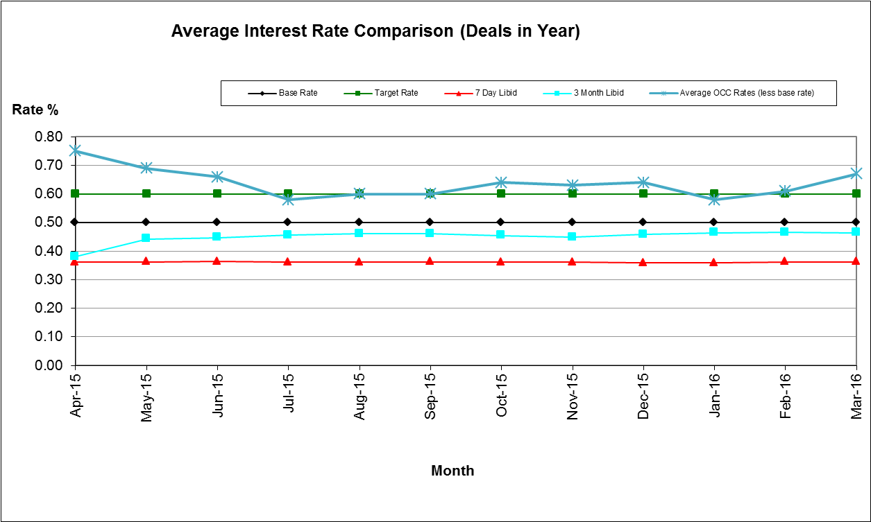
As illustrated above, the Council’s average monthly rate of return fluctuated around the benchmark throughout the year. It exceeded the benchmark for eight months, met the benchmark for two months and dropped below for two months.
The Council manages its investments in-house and invests with institutions listed in the Council’s approved counterparty list. The Council invests for a range of periods from overnight to 364 days, dependant on cash flow needs, its interest rate view, the interest rates on offer and durational limits set out in the Council’s Investment Strategy.
During 2015/16, the Council maintained an average investment balance of £74.8million and received an average return of 1.17%. This is above the target of 1% and is mainly due to investment in property funds. It is important to note that market rates have continued to drop throughout the financial year and that for many of the approved counterparties, the Council has not been able to achieve the same rate of return as in previous periods.
The Property Funds are classified as Non-specified Investments within the approved Strategy. The current rate of return on the investments is circa 4.05% per annum. The capital value of the Communities, Churches and Local Authorities Fund has increased by 28.32% since April 2013 and the Lothbury fund has similarly increased by 15.74% since August 2014. This capital value can also fluctuate downwards. However the Council joined the property funds as a long term investment because of the revenue stream. It is expected that the capital values will vary up and down in line with the property market and the overall position is monitored on a monthly basis. Since 31 March 2016 there has been a sharp reduction in the capital value of the property funds due to reductions in property values post-Brexit. The Council entered into the property funds to achieve a revenue return and, whilst the capital value has reduced, it is still significantly above the purchase value.
Actual investment income for 2015/16 was £0.86 million; this was marginally lower than the original budget of £0.94 million. Market rates continue to be very low and as security of investment is the Council’s primary concern, it has not always been possible to invest cash at more favourable rates.
Fluctuations in the Council’s balances have been managed through a mix of instant access and notice accounts, money market funds and short term deposits (up to 364 days). This approach is in line with the Investment Strategy approved by Council.

Interest Rates since 31 March 2016
The Council takes advice from Capita on the appropriate durations to place investments with counterparties. These durations and also the availability of individual counterparties change based on market conditions and the credit ratings of the individual institutions. This means that the investment portfolio has to be actively managed to ensure both the availability of enough suitable counterparties and that the Council achieves the best interest rates possible within the agreed security and liquidity parameters.
Following the result of the referendum on 23rd June 2016, there have been further downward pressures on interest rates. The Bank of England's Monetary Policy Committee did not adjust the Base Rate when it met in July, however the release of economic data showing that the Brexit implications were more significant than first thought meant that the MPC Committee cut bank base rate by 0.25% to a record low of 0.25% at its meeting on the 4th August. Capita have revised their interest rate forecasts and expect base rate to be cut further to 0.10% in December 2016. The forecast goes on to suggest no rise in base rate until quarter 2 of 2018.
Under the current market conditions, Money Market Funds (MMFs) are paying higher interest rates than many six-month investments. MMF rates as at the beginning of August are up to 0.52% and six month investments have been quoted at rates down to 0.16%. MMFs are amongst the most liquid of Council’s investment portfolio; they do not need the Council to give notice and, providing the Council requests funds by midday, the investment will be transferred into the Council’s bank account that same day. MMFs are ordinarily used to provide cash flow flexibility to allow money to be accessed and invested quickly and to deal with fluctuations in cash flow.
To take advantage of the preferential rates MMFs are currently offering the Council needs to increase the amount that can be invested in MMFs. It is therefore recommended that the 2016/17 Treasury Strategy is amended to allow an investment limit of £25 million in MMFs, an increase of £5 million on the current limit. The revised Specified Counterparty List is attached at Appendix 1 with the proposed change shown in bold italics.

Counterparty Changes
Following a tender process, Barclays Bank UK plc now provides the Council’s banking services.

Financial implications
- These are set out within the body of the report.

Legal issues
- The Council is required to report on its Treasury Management Function on an annual basis. This report meets that requirement.

Level of risk
- There are no risks in connection with the report’s recommendations. Risk assessment and management is a key part of Treasury Management activity, especially in the selection of counterparties when investment is being considered. The Council uses external advisors and counterparty credit ratings issued by the rating agencies to assist in this process.

Equalities impact
- There is no equalities impact relating to this report.

Report author | Bill Lewis
Job title | Financial Accounting Manager
Service area or department | Financial Services
Telephone | 01865 252607
e-mail | blewis@oxford.gov.uk

Background Papers: None

